Dr David Duncan 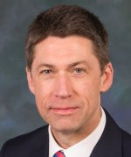
Chief Operating Officer and University Secretary

David Duncan is the University’s Chief Operating Officer and University Secretary. Prior to this, David was Registrar and Secretary at the University of York, a post he held for 8 years. Before then he was Secretary of the University of Dundee from 2001-8.

David is a graduate of the University of Aberdeen and holds a Masters degree and a PhD in history from Queen’s University, Canada.

